Eric Yang

304263623

CS181

Homework 2

1.

a.

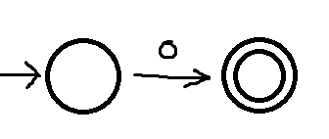

b.

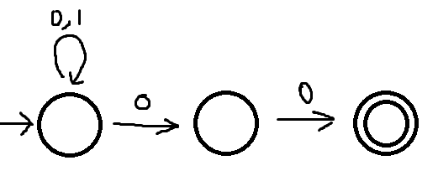

2.

a.

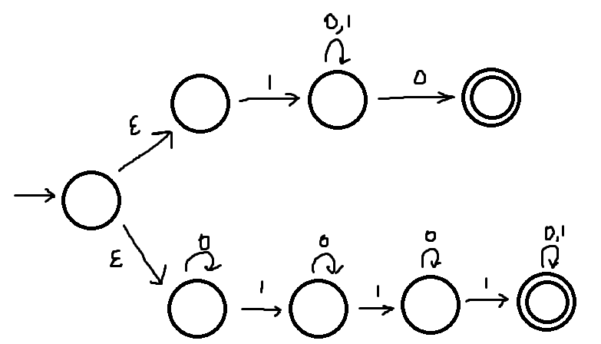

b.

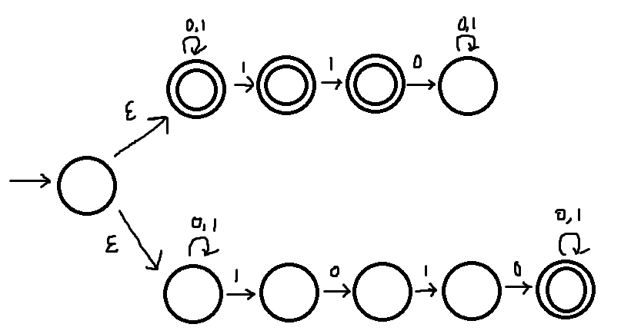

3.

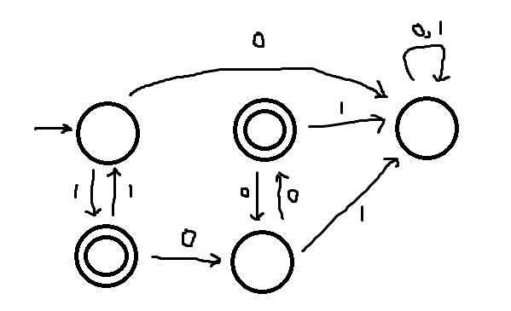

4.

NFA that finds 1s separated by odd symbols:

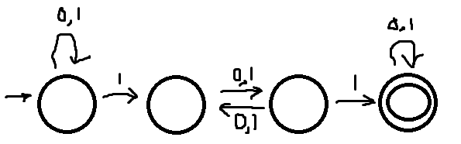

**DFA that finds 1s separated by odd symbols:**

**???**

5.

Swapping the accept and reject states of a NFA doesn’t create an automaton that recognizes the complement of L. A counter example would be an automaton with three states: 1,2,3 and alphabet {0,1} pictured below:

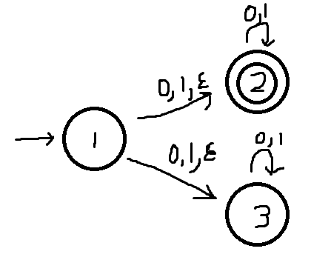

This automaton would accept every string. However, once we swap the accept and reject states, the automaton would still accept every string. Thus, swapping the states doesn’t create an automaton that recognizes the complement of L.

6.

For every value of n >= 1, create DFA with n states that loop in a circle with the only accept state being the start state. The current state only jumps to the next state if the input is 1 so that the length of the string is always multiple of n. Thus there is a DFA for every n >= 1.

7.

The language is regular since there is a DFA:

